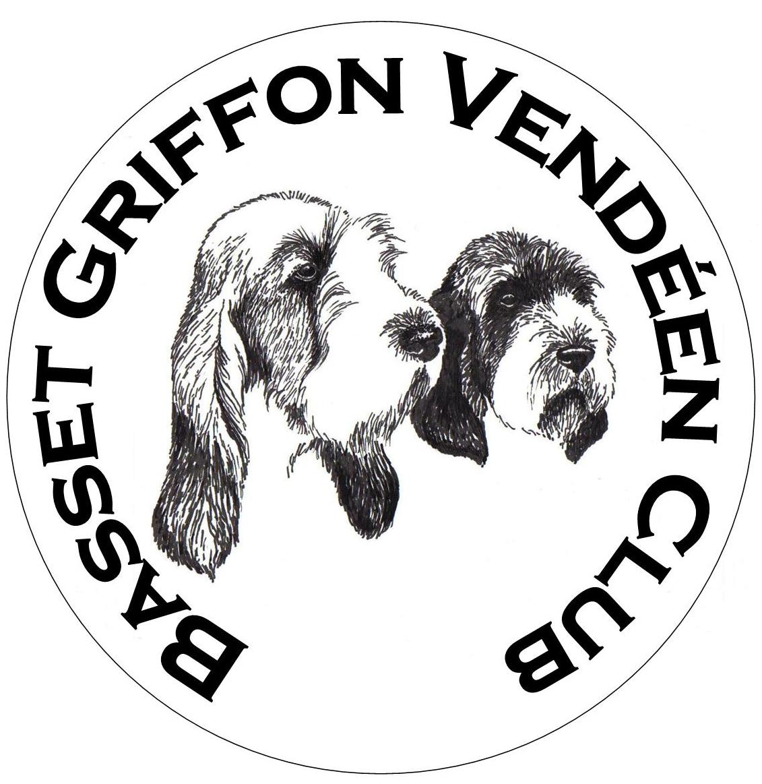
BASSET GRIFFON VENDÉEN CLUB
Points Form – Open Shows 2025

To be returned to: Claire Gilluley, 89 Russell Road, Bathgate, West Lothian, EH48 2GF
Tel: 07810 702280 E-mail: claireallen2612@hotmail.com

Claims cannot be considered unless this form is received by 28 February 2026
To claim for an award all joint owners must be members

There are awards for Top Dog, Top Bitch, Top Puppy, Reserve Top Dog, Reserve Top Bitch and Reserve Top Puppy.

Please complete a separate form if claiming more than one award.

Top Dog/ Top Bitch Point Awards | Puppy Point Awards

BIS | 5 points |  | BPIS | 5
RBIS | 3 points |  | RBPIS | 3
Single Group BIS | 4 points |  | Single Group BPIS | 4
Single Group RBIS | 3 points |  | Single Group RBPIS | 3
Sub-Group BIS | 3 points |  | Sub-Group BPIS | 3
Sub-Group RBIS | 2 points |  | Sub-Group RBPIS | 2
Group 1 | 4 points |  | Group 1 | 4
Group 2 | 3 points |  | Group 2 | 3
Group 3 | 2 points |  | Group 3 | 2
Group 4 | 1 point |  | Group 4 | 1
BOB or BAVNSC | 1 point |  | Puppy Group 1 | 4
 |  |  | Puppy Group 2 | 3
Sub-Group BOSIB | 1 point |  | Puppy Group 3 | 2
 |  |  | Puppy Group 4 | 1
 |  |  | BP or BP AVNSC | 1
 |  |  | BOB or BAVNSC | 1

Points Awards details

Where a dog is in joint ownership, every owner must be a club member.

A dog can compete for both puppy and adult awards in the same year, with points gained up to 12 months of age counting for the puppy award and points gained thereafter towards the adult award.

All points must have been awarded at shows between 1 January and 31 December 2025.

Please enter details of your dog’s wins overleaf

Points Form – Open Shows 2025

Registered Name of Dog |  | Breed Sex | Date of Birth
Sire | Dam
Breeder | Owner

Which trophy are you competing for? Tick box | TOP  DOG | TOP  BITCH | TOP  PUPPY

Date | Name of Show | Name of Judge | Award | Points | Running total

